**LAB 28**

**INTER-VLAN ROUTING WITH AN L3 SWITCH**

In the previous lab, we used VLANs on regular (L2) switches to separate different IP networks across multiple switches. These IP networks however could not communicate with each other, as routing is L3 functionality. Now, we’ll see how L3-switches can offer that functionality without having to add a router.

1. Download the PKA file “Lab 28 – Inter-VLAN routing on a L3-switch”. There you’ll find this topology:

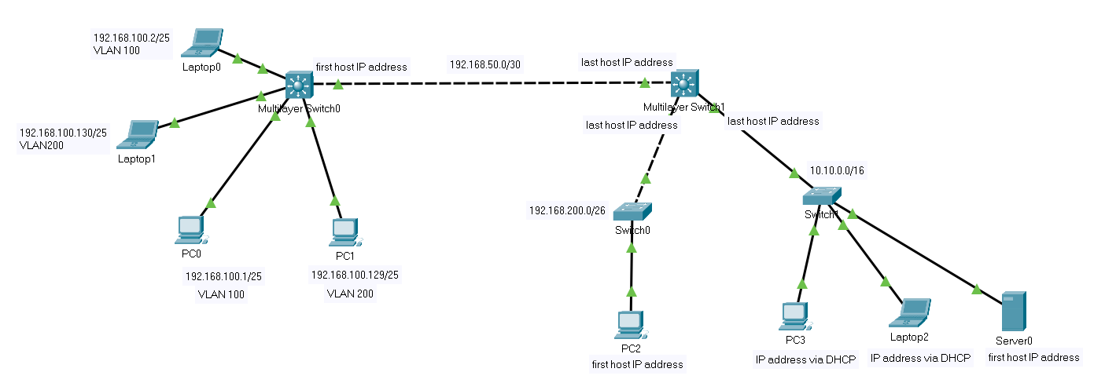

First, let’s first focus on the leftmost L3-switch (“Multilayer Switch0”) and its connected PCs and laptops. There are multiple VLANs we want to create for 2 different IP networks, similar to the previous lab, so consider the first steps as a quick recap exercise:

1. Little recap: Subnet masks conversion from prefix notation to dotted decimal notation should be fluently by now, so what is a /25? You could use ipcalc to verify that and to verify that PC0 and Laptop0 are in a different IP network than PC1 and Laptop1.

255.255.255.128

1. Now, configure the IP addresses and subnet mask as indicated for the PCs and Laptops connected to that leftmost L3-switch.
2. Create VLAN ID 100 with the name “students” and VLAN ID 200 with the name “lecturers” (use these names exactly in lower case) and assign the correct interfaces to the correct VLANs. This is similar to previous lab. Verify that you can ping from PC0 to Laptop0 and from PC1 to Laptop1.

You’ll notice that pinging between the 2 IP networks doesn’t work yet (e.g. from PC0 to PC1). As we are now using an L3-switch this “Inter-VLAN routing” can be made possible however (contrary to previous lab with L2-switches only)!

1. To this end, we need to create an SVI on the switch for each VLAN, with an IP address within the IP network that is used on that VLAN. Use *the last host IP address* in each network (with correct subnet mask) to assign to each SVI. See lecture slides on creating the SVIs.

Note: Mind the difference between the command ***vlan <vlan_id>*** for creating a VLAN and the command “***interface vlan <vlan_id>***” for configuring the SVI

1. Of course, your PCs and Laptops need to configure that they will use that SVI’s IP address to reach others networks, i.e. setting this as default gateway (just as if this would be the IP address of a neighboring router interface).
2. Check if you can actually ping from one IP network to another (e.g. from PC0 to PC1). If it doesn’t, make sure you didn’t forget that on a L3-switch you need explicitly to enable IP routing (contrary to a router).
3. Having L3 functionality, thus means you now also have a routing table. Paste below a screenshot of the contents of the route table on the switch.

Is there a default route defined here?

No

1. Give the L3 switch your first name.

Now, let’s turn our attention towards the rightmost L3-switch (“Multilayer Switch1”) and its network connections to the ‘ordinary’ Switch0 and Switch1. Note that, contrary to the leftmost L3-switch, each IP network is on a separate physical link. So in this case, there’s no need to specify VLANs on this switch. Here, the L3-switch could have been replaced by a router as well. Thus, an L3-switch doesn’t imply VLANs per se.

1. Now, to make a switchport of an L3-switch work just like a router interface, we’ll need to explicitly to configure it as a **‘routed port’** (this is not the same as an SVI used for VLANs, see lecture slides).

After all, a physical L3 switch port is defined as an L2 port by default. In other words: *by default, you cannot assign an IP address to an L3 switch port!* To make this possible, and thus make it a ‘routed port’, you will need to use the command below for each physical L3 switch port before you can effectively assign an IP address to it.

***no switchport***

Now, apply this to the interfaces of this L3-switch, which are connected to Switch0 and Switch1. As indicated, use the last host IP address of each network on these routed ports (note the different network prefixes, use ipcalc to verify).

Finally, just as you did on the other L3-switch, don’t forget to explicitly enable IP routing (as this is not enabled by default on L3-switches)

1. Now, set correct IP configuration (IP, subnet mask, gateway) for PC2 and Server0
2. Then, configure Server0 to enable the DCHP service and configure the DHCP pool to include all unused host IP addresses in its network. Specify the default gateway for the DHCP clients as well. Make your changes within the default pool “serverPool”, but do not change that name.
3. Enable PC3 and Laptop2 to use DHCP.
4. As 192.168.200.0/26 and 10.10.0.0/16 are two ‘directly connected networks’ (cfr lecture on IP routing), and you’ve configured all clients, you should be able to ping from e.g. PC3 to PC2.

We still have to configure the connection between both L3-switches. But now that’s a piece of cake (well, almost) because it’s a similar situation as we just had configured: the link is an L3 link on which a single IP network is used. We don’t need L2 VLAN access or trunk ports. We can thus again convert the switchports for that link for both L3-switches to a ‘routed port’.

1. Create the ‘routed ports’ on both L3-switches, using the indicated host addresses within the 192.168.50.0/30 network.
2. Check if you can ping from a host in any of the networks attached to the leftmost L3-switch to a host in any of the networks attached to the rightmost L3-switch (e.g from PC0 to PC2).

This will not normally work because both L3 switches have remote networks, for which no routes are currently known, see lecture/lab on IP routing.

How many remote networks does the leftmost L3-switch have?

2

These can be reached via the same neighboring IP address, thus you can solve this by adding a default route. And similarly on the other L3-switch.

1. Check again if you can ping from e.g. PC0 to PC2. Now, every host should be able to communicate with any other host in your network.
2. Save the current configuration to the startup-config (in NVRAM) on both L3 switches.
3. Save PKA file and upload it to Leho.